Multiple-choice section

|  |  |  |  |  |  |  |
| --- | --- | --- | --- | --- | --- | --- |
| Question | 1 | 2 | 3 | 4 | 5 | 6 |
| Answer | C | B | D | D | B | C |

Question 1 [7.1]

C

Mark the letters O, A and H on the diagram.

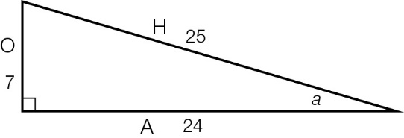



Question 2 [7.2]

B

Mark the letters O, A and H on the diagram.

|  |  |
| --- | --- |
| ACPM9_PR_7_02wssb | sin(*b*) ==  =  *x* = × 24  *x* = 6 |

Question 3 [7.3]

D

Mark the letters O, A and H on the diagram.

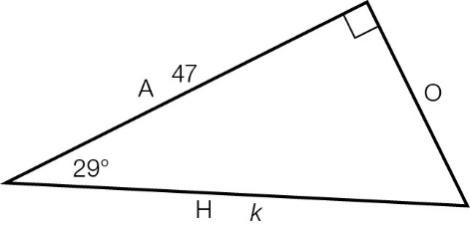

A and H are used, so use the cos ratio: cos(29°) = 

Question 4 [7.5]

D

Draw the diagram.

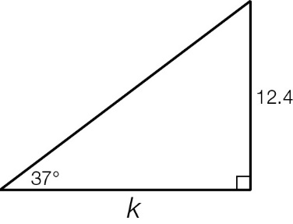

tan(37°) = , so *k* = 

*k* = 16.5 m

Question 5 [7.5]

B

214°T is between S (180°T) and W (270°T). it is 34°W of S (214 − 180 = 34), so we write it as S34°W.

Question 6 [7.4]

C

Mark the letters O, A and H on the diagram.

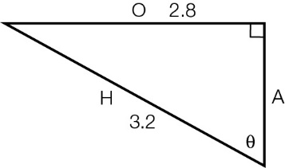

O and H are used, so use the sine ratio: θ = sin-1

Multiple-choice total marks: 6

Short answer section

Question 7 4 marks [7.3]

**(a)**

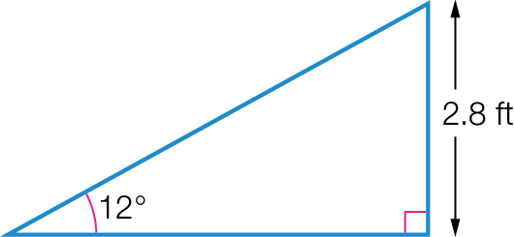

|  |  |
| --- | --- |
| **(b)** | sin(θ) =  θ = 12°  opposite side = 2.8 ft  sin(12°) =    *x* = 13.5 ft |

Question 8 5 marks [7.5]

**(a)** cos(θ) = 

cos(52°) = 

*x* = 50 × cos(52°)

*x* = 30.8°

The bus travels 30.8 km north from its starting point.

**(b)** N52°W is in the top left-hand quadrant and 52° short of 360°.

true bearing = 360° – 52° = 308°T

Question 9 5 marks [7.1]

|  |  |
| --- | --- |
| **(a)**  ACPM9_PR_7_08wssb_RR | **(b) (i)** sin θ =  **(ii)** cos θ =  **(iii)** tan θ = |

Question 10 6 marks [7.2]

|  |  |
| --- | --- |
| (a)  **ACPM9_PR_7_09wssb_RR** | sin(θ) =  sin(51°) =  *x* = 17.4 × sin(51°)  *x* = 13.5 m (1 d.p.) |
| **(b)**  ACPM9_PR_7_10wssb | tan(θ) =  tan(22°) =  *b* =  *b* = 140.3 m (1 d.p.) |
| **(c)**  ACPM9_PR_7_11wssb | cos(θ) =  cos(63°) =  *z* =  *z* = 47.8 (1 d.p.) |

Question 11 6 marks [7.4]

|  |  |  |
| --- | --- | --- |
| (a) cos(θ) =  θ =  θ = 38° | (b) sin(θ) =  θ =  θ = 40° | (c) tan(θ) =  θ =  θ = 29° |

Question 12 5 marks [7.2]

|  |  |
| --- | --- |
| **(a)** *x*2 + 352 = 372  *x*2 = 372 – 352  *x*2 = 1369 – 1225  *x*2 = 144  *x* = 12  The opposite side is 12 cm. | **(b)** sin(θ) =  sin(θ) =  cos(θ) =  cos(θ) =  tan(θ) =  tan(θ) = |

Question 13 3 marks [7.5]

|  |  |
| --- | --- |
| (a)  ACPM9_PR_7_12wssb | (b) tan(38°) =  *h* = 160 × tan(38°)  *h* = 125.0 m (1 d.p.) |

Question 14 3 marks [7.3]

Call the base (diameter) of the semicircle *H*.

cos(30°) = 

*H* =  = 14.4337 mm (so the radius is 7.2168 mm)

Arc length = 

= 

= 

= 22.6724

To find the perimeter we need to add the arc length to the diameter:

22.6724 + (2  7.2168) = 37.1061

The perimeter of the semicircle is 37.1 mm (1 d.p.).

Short answer total marks: 37

Extended answer section

Question 15 7 marks [7.3, 7.4]

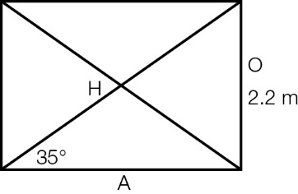

(a) Length of a horizontal beam:

tan(35°) = 

A = 

A = 3.1419 m

Length of a diagonal beam:

sin(35°) = 

H = 

H= 3.8356 m

total length of wood required = 2(2.2 + 3.1419 + 3.8356) = 18.36 m (2 d.p.)

(b)

**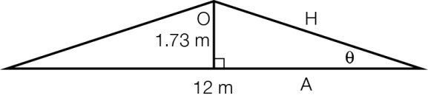**

**(i)** tan(θ) = 

θ = tan -1

θ = 16.1° (1 d.p.)

**(ii)** To find the length of the diagonal beams:

sin(16.1°) = 

H = 

H = 6.23 m

total wood needed for frame = 12 + 1.73 + 2 × 6.23 = 26.2 m (1 d.p.)

Question 16 6 marks [7.5]

|  |  |
| --- | --- |
| **(a)** tan(θ) =  θ = 25°  Length of adjacent side = 35 m  tan(25°) =  *h* = 35 × tan(25°)  *h* = 16.32 m | **(b)** tan(θ) =  In Δ*ADC*, tan(θ) =  *DC* = *BC* – *BD*  = 35 – 12  = 23  tan(θ) =    θ = 35° |

Extended answer total marks: 13

TOTAL test marks: 56